Images in Plane and Curved Mirrors: Worksheet
Science 8 2013
Name: ______________________________________
Images in Plane Mirrors
- What are the four characteristics of images in plane mirrors? (page 190)

a) the image is the same size
b) the image distance is equal to the object distance
c) the image is upright
d) the image is virtual

- Give 4 examples of plane mirrors (page 191)

a) rearview mirror in a car
b) dentist mirror
c) periscope
d) inspection mirror

- Analysis: Why would someone use a plane mirror? (think about the image it creates)

The image created looks exactly like the object that it reflects except that it is reversed. A plane mirror is useful when you want to view the object exactly as it is: that is you do not want the image to be distorted in anyways (example: bathroom mirror when getting ready in the morning- when getting ready you wouldn’t want your image to be distorted- you want to know exactly how you look)

Images in Curved Mirrors
- A concave mirror has a reflective surface that curves inward. (page 196)
- A convex mirror has a surface that curves outward. (page 196)
- Draw a sketch of a concave and a convex mirror in the space below:

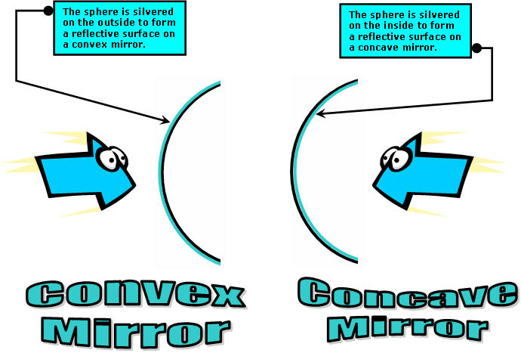

- Describe how an image would look in a concave mirror such as a make-up mirror (look at Figure 5.25 on page 200)
Although there are different types of concave mirrors, the image created in the concave mirror like a make up mirror, creates an image larger than the object. You see the object in more detail but you might see less of it. Make up mirrors are often concave so a person can see a larger more detailed image of their face
- List 5 uses of concave mirrors (page 203)
a) flashlight
b) spotlights
c) overhead projectors
d) car headlights
e) lighthouses
- Convex mirrors produce an image that is smaller than the object being reflected. (page 206)
- More objects can be seen in a convex mirror than a plane mirror of the same size (page 206)
- Why would a convex mirror be used for a security mirror or an outside mirror on a bus? (page 206)
A convex mirror would be used for security as you are able to monitor a larger area from a single location. Objects are smaller so you see more of the area. Same with bus mirrors. Convex mirrors can widen the view of traffic that can be seen in the bus mirror. Drivers are able to monitor the students better.
- Give four examples of convex mirrors (page 206):
a) Disco ball
b) Outside mirror on a bus
c) Security mirror
d) Traffic mirror on side of buildings
e) some streetlights ** added this in

