Grade 8 Science
Chapter 2 and part of 3 Review Sheet

Name: _____ANSWERS_____________

- (a) What is the normal range for the following abiotic factors in a healthy river? *Provide quantitative measurements.

Abiotic Test | Normal Range
*Dissolved Oxygen | 8 ppm
*pH | 5.5 - 8
Water Temperature | Low or High
Phosphates | Low or High
*Turbidity | 0 – 40 JTU or 1 - 2 ppm

(b) Calculate the biotic index for the following stream sample:

Organism Name | # of Organisms | Point Value
Stonefly Nymph | 4  | 3 = 12
Mayfly Nymph | 3 | 3 = 9
Leeches | 5 | 1 = 5
Dragonfly Nymph | 3 | 2 = 6

Total Biotic Index: __32 (12 + 9 + 5 + 6) __

(c) Based on page 109 of your text book, what is the water quality rating for this stream?

____Good/Excellent____

2. (a) What is an ocean basin?
A large “hole” in the Earth’s surface (usually greater than 2000 m) that holds ocean water.

(b) How were the ocean basins’s first formed?
According to some scientists, the Earth’s continents were thought to have been all together in a super continent called Pangea. The magma, in the Mantle, oozed up through the plate cracks forcing the continents away from each other, thereby forming a volcano/ridge. Subsequently, this provided “space” for an ocean to form.

(c) Scientists speculate that most of the water that originally formed the oceans several billion years ago came from these TWO (2) different sources: (i) Volcanoes (ii) Comets

3. What is an Ice Age?
Extended periods of glaciation.
4. Label the following diagram of the ocean floor.
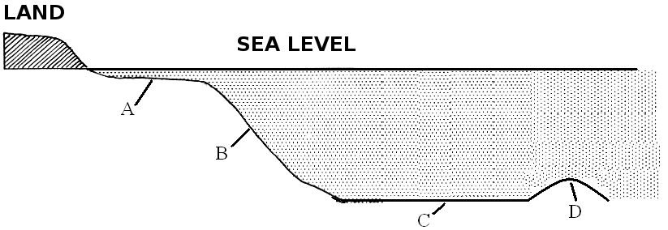A = Continental Shelf
B = Continental Slope
C = Abyssal Plain
D = Ridge/Volcanoe

5. Complete the following table.
Ocean Floor  Feature | Illustration | How was it formed?
Volcanoe / Ridge | 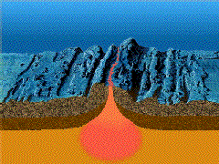 | When magma pushes its way to through the Earth’s Crust, pushes the Tectonic Plates apart and then cools and hardens.

6. What is the Earth’s largest ocean current?

Antarctic Circumpolar Current.

7. What is a current?

A large body of water moving in one unchanging direction.

8. (a) What are the TWO (2) currents that effect Newfoundland and Labrador? Indicate (in brackets) if this current is warm or cold.

- Gulf Stream ( Warm )
- Labrador Current ( Cold )

(b) What effects do these currents have on our province?
The Gulf Stream and Labrador Current have a moderating effect (i.e. help to prevent extremes in seasonal weather) on NL; keeping winter temperatures warmer and summer temperatures cooler when compared to other inland provinces in Canada.

9. (a) Fill in the table below.

Oceanic Process | Illustration | Description
Upwelling | 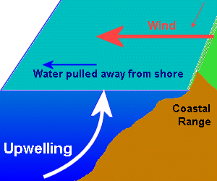 | Upwelling is an oceanographic phenomenon that involves wind-driven motion of dense, cooler, and usually nutrient-rich water towards the ocean surface, replacing the warmer, usually nutrient-depleted surface water.

(b) Why is upwelling important for marine life ?

Upwelling brings nutrients with the cooler water, which is great for plants, organisms and the entire food chain.

10. (a) What are waves?

Large ripples set in motion by steady winds. Waves on the surface of water are the result of a transfer of energy from moving air to the water.

(b) Fill in the table below.
Type of Wave | Illustration | Caused by….
Swell | 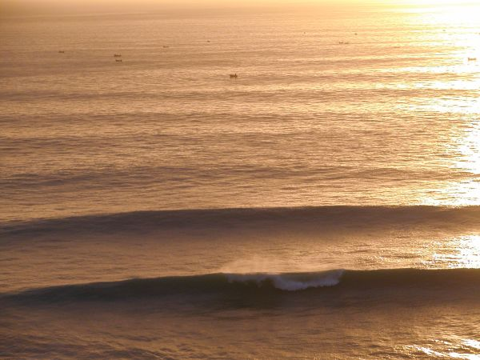 | Wind + Storms at sea.
Breaker | 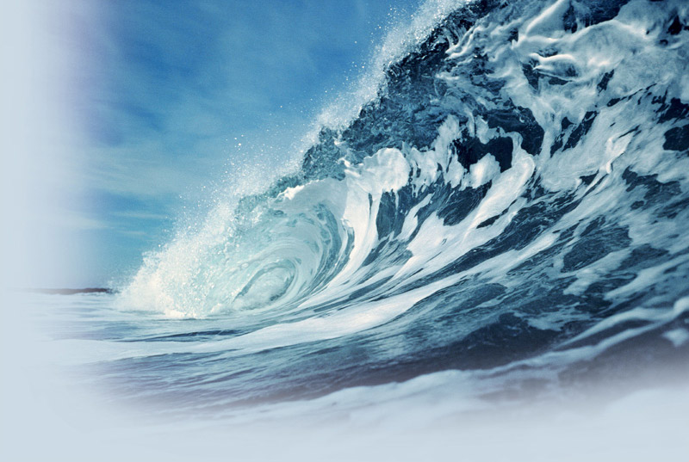 | Wind + a Shoreline, whereby the wave can decrease in length, increase in height and eventually fall (break) over itself.

11. (a) What are tides? What causes tides?

The slow rise and fall of the ocean that is caused by the gravitational force of the moon.

(b) Fill in the table below.

Type of Tide | Illustration | Description
Neap Tide | 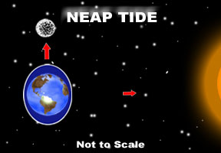 | - Occur when the Sun and the Moon are at right angles to one another.  - Causes the smallest tidal movements. There is little difference between low and high tides.
Spring Tide | 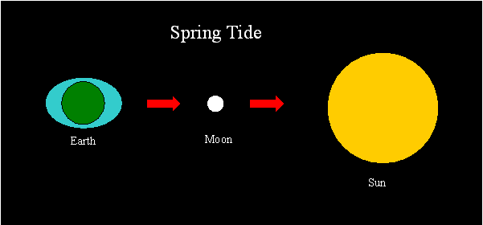 | - Occur when the Earth, Sun and Moon are in a straight line.  - Causes extra high and low tides.

12. Fill in the table below.

Shoreline Feature | Illustration | Description/How formed?
Headland | 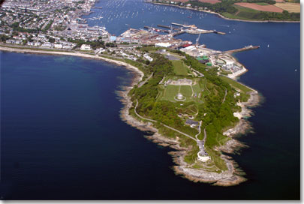 | Areas of land that are surrounded by water on three sides. Headlands are long peninsula’s that come out from the shoreline, into the ocean.
Bay | 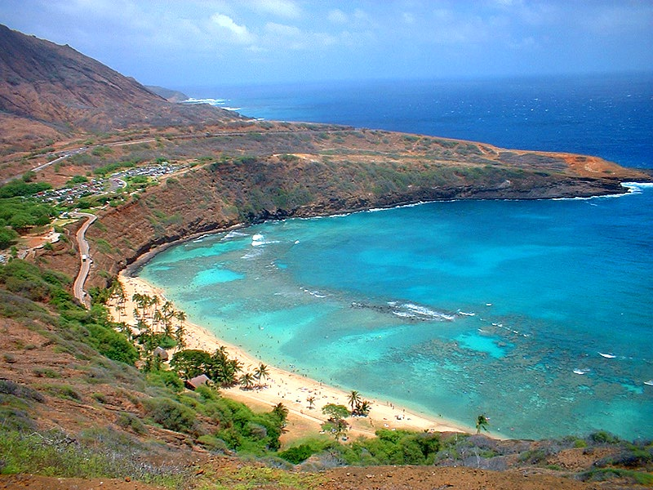 | Bodies of water partly enclosed (and protected) by land. A bay may be meters across, or it could be hundreds of kilometers across.
Sea Arch | 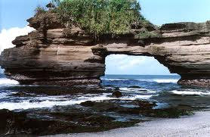 | Along some rocky shorelines, waves may slowly wear away the rocks and eventually form hollows. Over time, these hollows enlarge and become caves. As the caves increase in size, they eventually meet and a sea arch is formed. When too much erosion occurs, overhanging rock may fall of into the ocean.
Sea Cave | 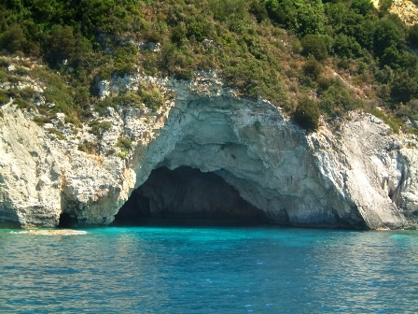 | A sea cave is a type of cave formed primarily by the wave action of the sea. Typically, sea caves are formed when waves (over longs periods of time) beat against cliffs, eroding the rock away, especially where weaker layers of rock may exist.
Sandbar or Shoal | 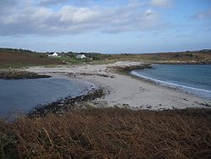 | A shoal or sandbar is a long mass or low ridge of submerged or partially exposed sand built up in the water along a shore or beach by the action of waves or currents.
Beach | 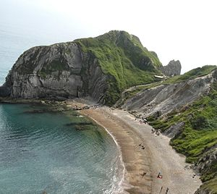 | Beaches are built up over time by the addition of sediment. Sediment is a term meaning particles of rock or earth produced from larger particles over time. The weathering of rocks by wind, rain, ice and geological processes causes their breakdown into smaller units, which then undergo a process known as erosion.
Sea Stack | 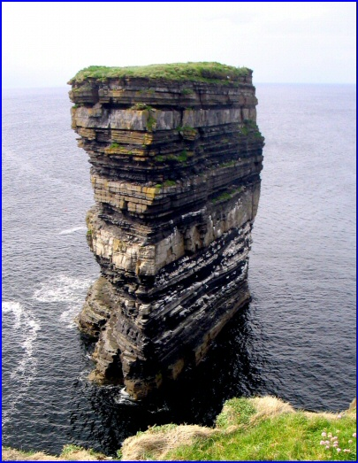 | Sea Stacks are steep and often vertical column(s) of rock in the sea near a coast which may be caused by wave action, eroded headlands or the collapsing of sea arches.

13. (A)
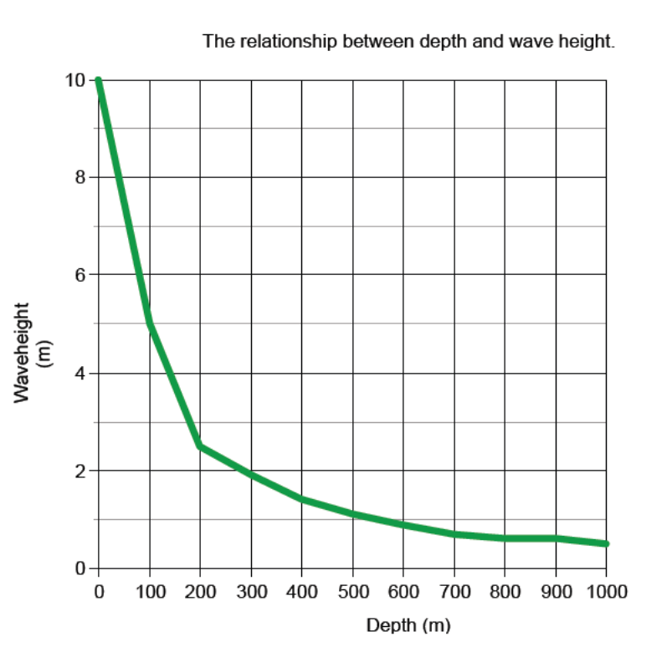

(B) What is the independent variable? Depth (m)

(C) What is the dependent variable? Waveheight (m)

(D) Estimate the height of the wave at a depth of 350 m. ~ 1.6 – 1.8 m

(E) Estimate the depth where the wave is a height of 3 m. ~180 - 190 m

(F) Imagine you are a fisherman on the water when you hear a tsunami warning. Would it be safer to move to deep water or to shallow water? Explain your choice.

If you were on the water and heard a tsunami warning if would be safer to move to deeper water. The deeper the water is, the smaller the wave height. For example at water a depth of 1000 m, the wave height is only ½ a meter. The closer you get to shore (and the shallower the water) the higher the wave. So it would be safer to be farther out where the wave height is less.

