Grade 8 Science
Chapter 2 and part of 3 Review Sheet

Name: ________________________

- (a) What is the normal range for the following abiotic factors in a healthy river? *Provide quantitative measurements.

Abiotic Test | Normal Range
*Dissolved Oxygen
*pH
Water Temperature | Low or High
Phosphates | Low or High
*Turbidity

(b) Calculate the biotic index for the following stream sample:

Organism Name | # of Organisms | Point Value
Stonefly Nymph | 4 | 3
Mayfly Nymph | 3 | 3
Leeches | 5 | 1
Dragonfly Nymph | 3 | 2

Total Biotic Index: ___________

(c) Based on page 109 of your text book, what is the water quality rating for this stream?

_________________________________________________________

- (a) What is an ocean basin?
______________________________________________________.
(b) How were the first ocean basin’s formed?
____________________________________________________________________________________________________________.
(c) Scientists speculate that most of the water that originally formed the oceans several billion years ago came from these TWO (2) different sources: (i) ____________________ (ii) _____________________

3. What is an Ice Age?
_______________________________________________ _______________________________________________.
4. Label the following diagram of the ocean floor.
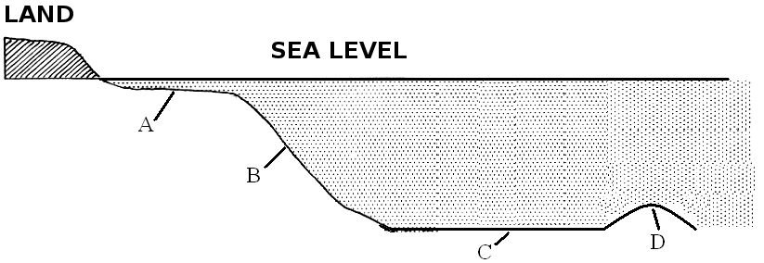A = ___________________________
B = ___________________________
C = ___________________________
D = ___________________________
5. Complete the following table.
Ocean Floor  Feature | Illustration | How was it formed?
 | 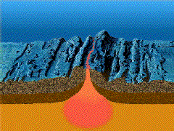

6. What is the Earth’s largest ocean current? ____________________

7. What is a current?

____________________________________________________.

8. (a) What are the TWO (2) currents that effect Newfoundland and Labrador? Indicate (in brackets) if this current is warm or cold.

(i)__________________________ ( )
(ii)__________________________( )

(b) What effects do these currents have on our province?
________________________________________________________________________________________________________.

9. (a) Fill in the table below.

Oceanic Process | Illustration | Description
Upwelling

(b) Why is upwelling important for marine life ?

________________________________________________________________________________________________________.

10. (a) What are waves?

____________________________________________________
____________________________________________________.

(b) Fill in the table below.
Type of Wave | Illustration | Caused by….
Swell

 | 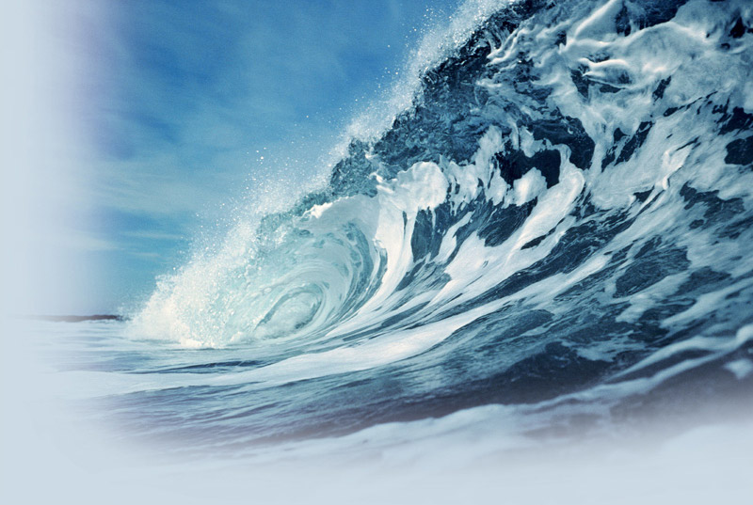

11. (a) What are tides? What causes tides?

____________________________________________________________________________________________________________________________________________________________.

(b) Fill in the table below.
Type of Tide | Illustration | Description
Neap Tide

Spring Tide

12. Fill in the table below.

Shoreline Feature | Illustration | Description/How formed?
Headland

Bay

Sea Arch

Sea Cave

Sandbar or Shoal

Beach

Sea Stack

13. Tsunamis are large waves caused by earthquakes, landslides, volcanoes or even meteorites. As a tsunami approaches the shore, the front end of the wave slows quickly compared to the back end which is still trying to move forward at a great speed. The result is, water at the front end of the wave gets pushed upward. Think of it like a long line of traffic speeding down a straight highway. All of a sudden, the front car hits the brakes and the cars behind keep ramming into the back of each other creating a pile up. This explains why tsunamis are so high and why they push forward with such force. The data below illustrates the change in the wave’s height as a tsunami approaches the shore:
Depth (m) | Wave height (m)
1000 | 0.5
900 | 0.6
800 | 0.6
700 | 0.7
600 | 0.9
500 | 1.1
400 | 1.4
300 | 1.9
200 | 2.5
100 | 5
0 | 10
(A) Make a line graph of the data on the grid provided.
Title: ______________________________________________

(B) What is the independent variable? ________________________

(C) What is the dependent variable? _________________________

(D) Estimate the height of the wave at a depth of 350 m. ___________

(E) Estimate the depth where the wave is a height of 3 m. ___________

(F) Imagine you are a fisherman on the water when you hear a tsunami warning. Would it be safer to move to deep water or to shallow water? Explain your choice. ____________________________________________________________________________________________________________________________________________________________________________________________________________________________________

