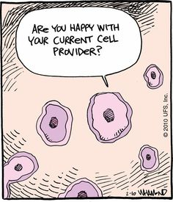  The Cell Theory:  - All organisms are composed of one or more cells.  - All cells must come from other living cells.  - The cell is the smallest/ basic unit of life.
  Cell Information:
  Some organisms are unicellular:
  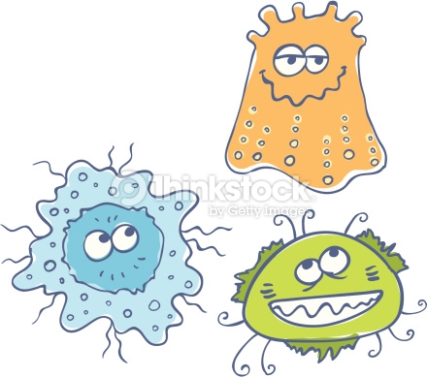
  Multicellular organisms have many types of specialized cells:
  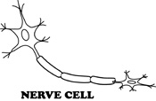
  Cells contain hereditary DNA:
  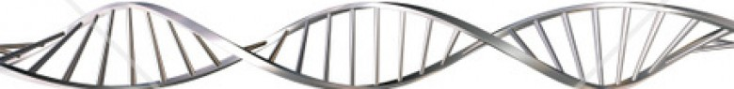
  The processes occurring in a cell:
  - Grow and Reproduce
  - Respond
  - Use Energy
  Name: ______________________
  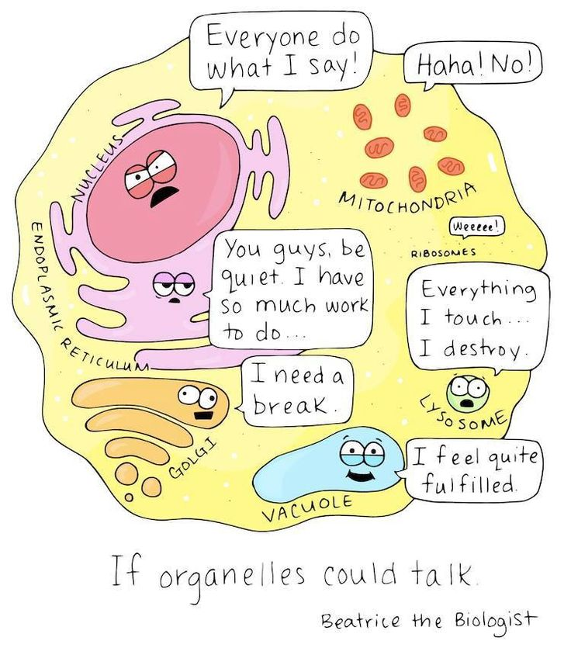
  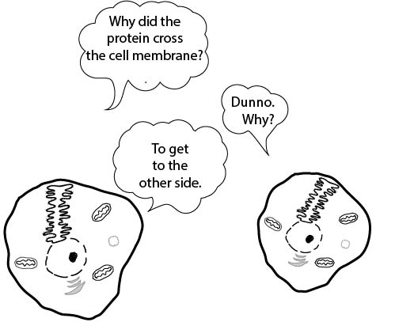
  Cells – Unit 4 Grade 8 Science
  Name: ___Key___
  _

Draw, label and color an ANIMAL CELL below. Be sure to include all organelles:  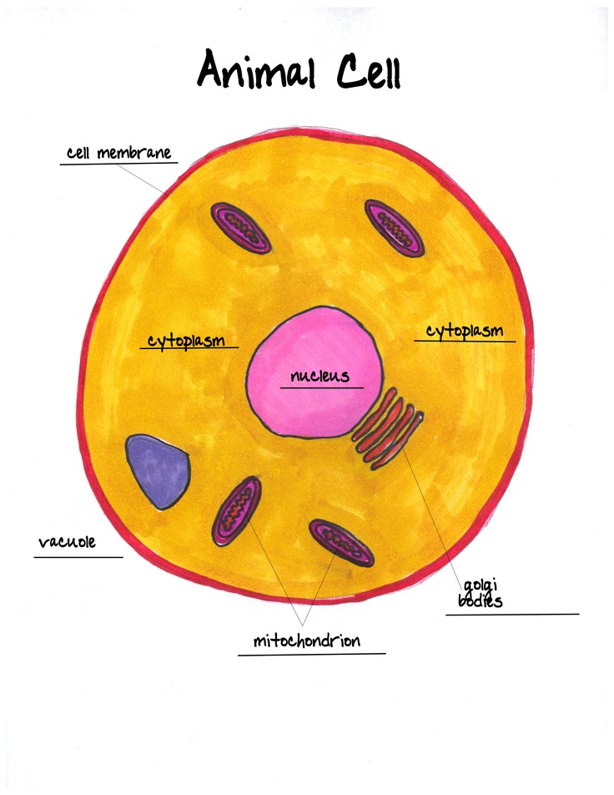 |  |  | Explain the main function(s) of each cell organelle:  Vacuole: (A/P) Storage for food, nutrients, and waste. Bigger in plant cells; smaller in animal cells. Nucleus: (A/P) “Brain” of the cell/controls transport. Contains DNA/Genetic material. Mitochondria: (A/P) Produces energy for the cell. CellMembrane: (A/P) Thin layer surrounding the cell. Allows proteins and nutrients into the cell and waste to leave the cell. Cytoplasm: (A/P) Jelly like substance that is the transport system for the cell. Supports the organelles. CellWall: (P) Rigid outer layer of the plant cell that gives the cell the box-like shape. Chloroplasts:(P) Gives plant cells their green color due to the presence of chlorophyll. Converts sunlight into sugar (via photosynthesis).  A= Animal Cell P = Plant Cell |  |  | Draw, label and color a PLANT CELL below. Be sure to include all organelles:  

