The Six Properties of Light

1. Rectilinear Propagation
- Light travels in a straight line.
- This property is called rectilinear propagation.
- This characteristic allows us to predict shadows and forms that would be created by light rays.
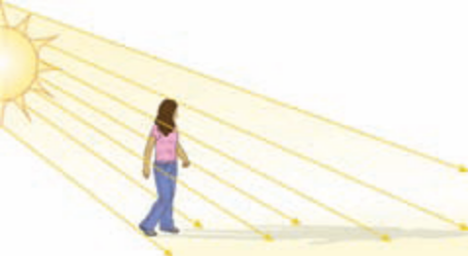
Figure 5.6 Ray diagrams can show how shadows are cast.

- When light rays shine against an object, the object projects a shadow because it blocks the sun’s rays that hits it. 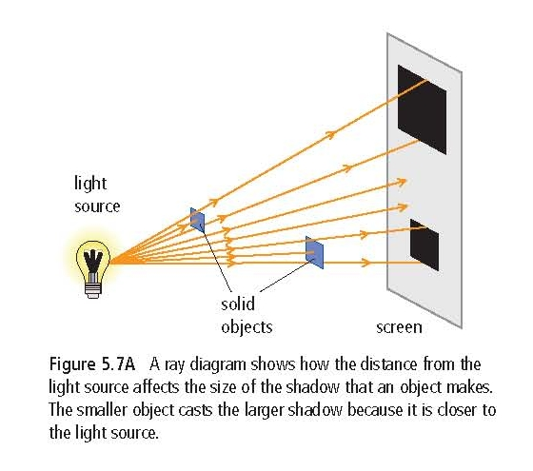

2. Can travel through a vacuum

- Light can travel without particles.

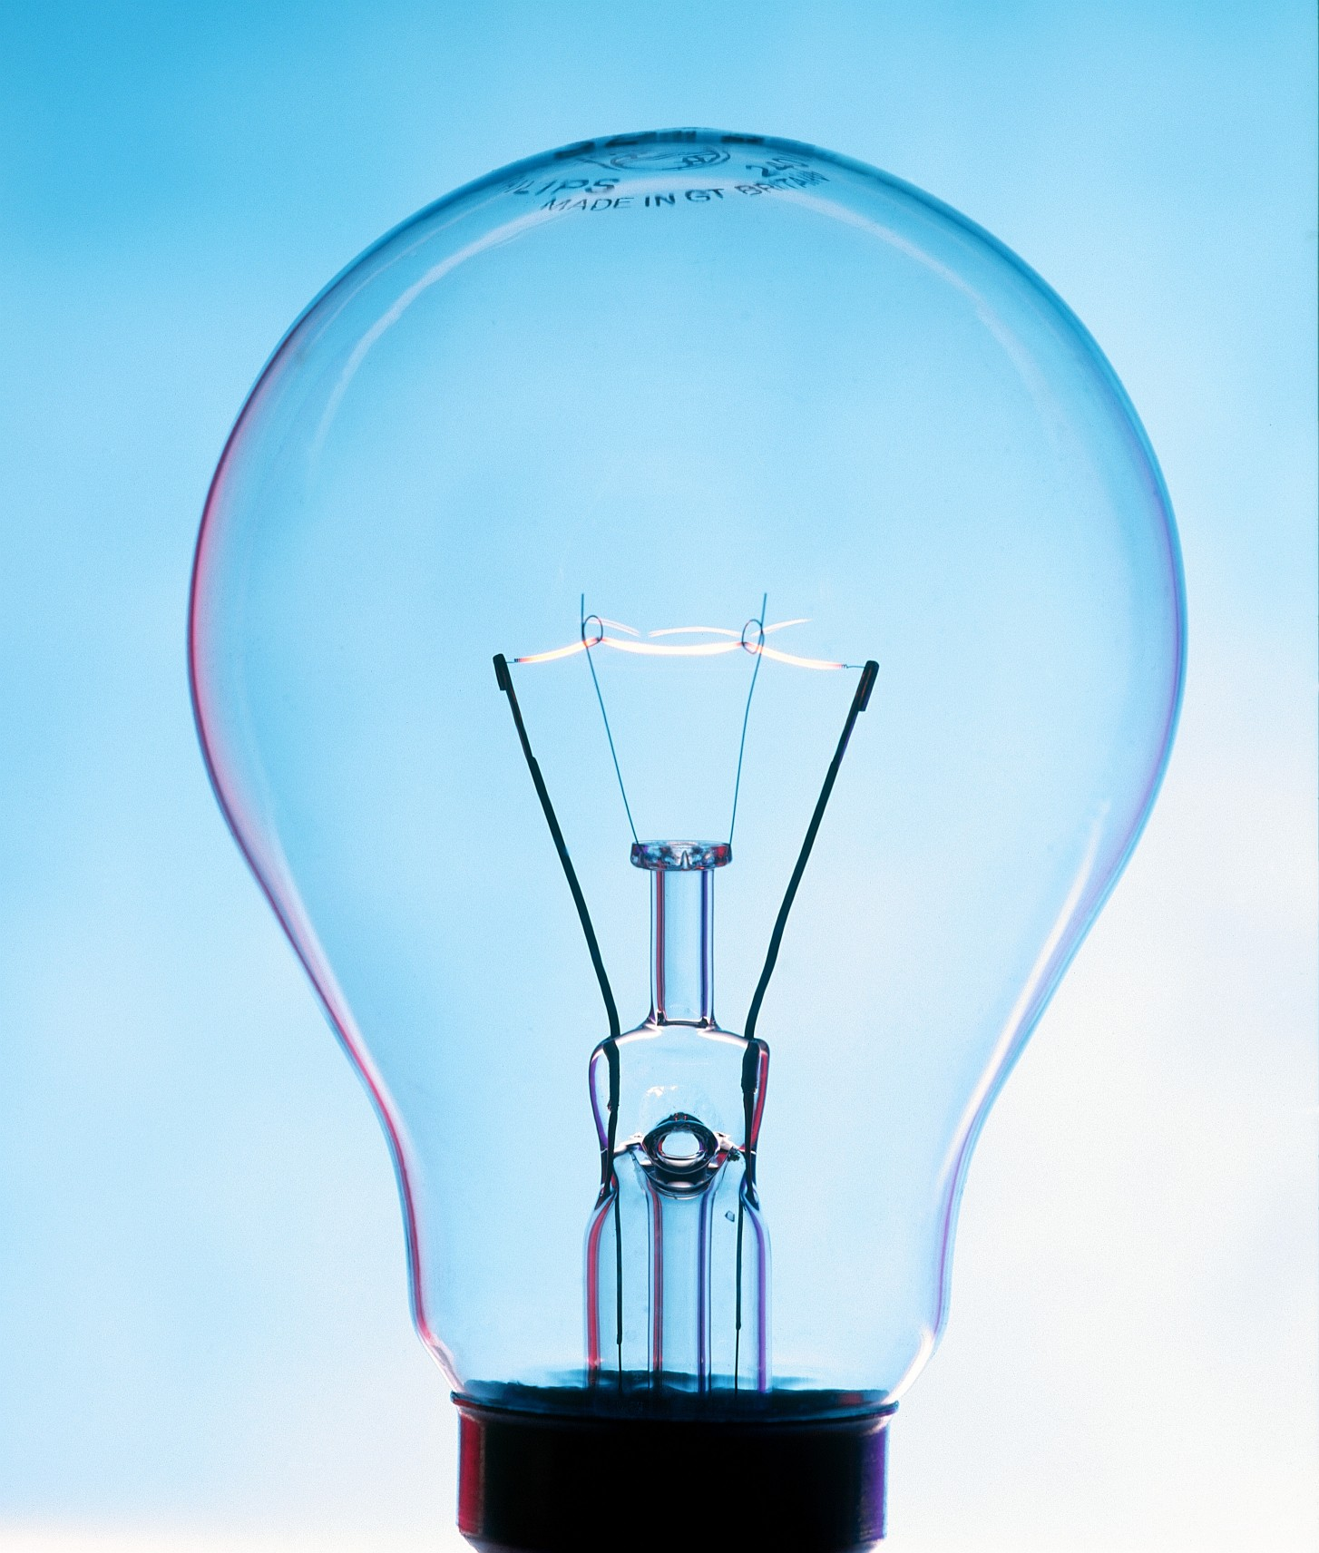

Light travels in a light bulb from the tungsten filament out through the glass without any air particles.

The lack of air is why there is a popping noise when you break a light bulb.

3. Light and the type of material

i) Transparent :
- When the light passes through a clear material, the light rays continue their straight movement in a straight line.
- We say that these materials are transparent.
- Air, water, and glass are examples of things that are transparent.

ii) Translucent :
- With a translucent material, like frosted glass, most light rays pass through but are then scattered in all directions.
- Translucent materials do not permit one to see the objects clearly.
- Examples : windows in a bathroom

iii) Opaque :
- A material that blocks out all of the light.
- No light can travel through the material

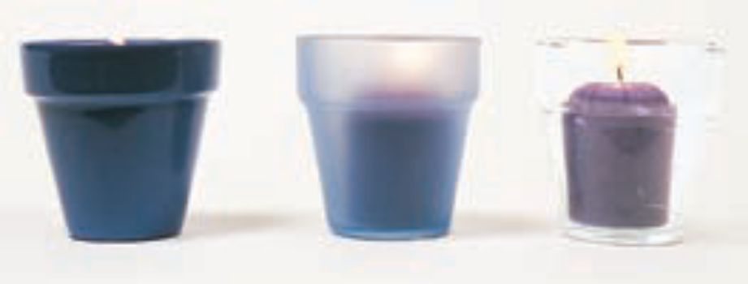
Opaque Translucent Transparent

4. Reflection
- Light can be reflected.
- If the light reflected on a smooth surface forms an image in the area surrounding it, the reflection is called specular reflection. Ex : a mirror
- If the light reflected on a surface does not form a clear image, but permits you to see what is found on a surface, the reflection is diffuse. Ex : paper
*Diagram: Specular and Diffuse reflection
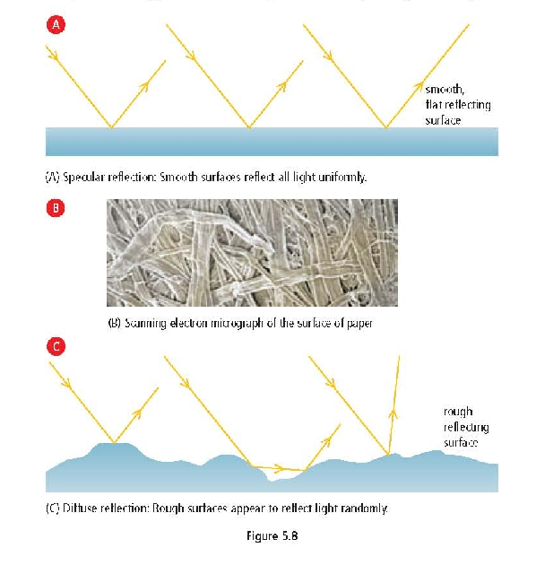
- The trajectory of the rays reflected by the white parts of the paper orient themselves towards your eyes. The written letters do not reflect any of the light rays.

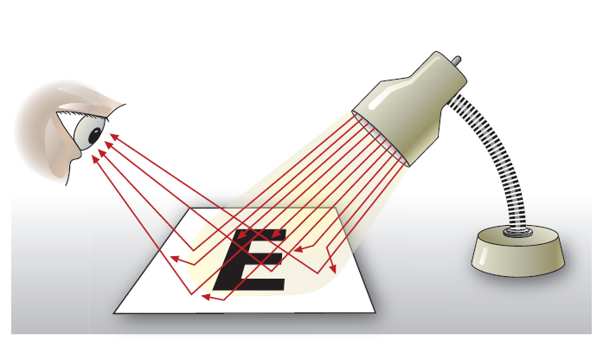
- Diffuse reflection is what allows you to read what is printed on the paper.

5. Refraction

- Refraction is the change of direction of a wave when it passes from one substance to another.
  - Example : from air to water.

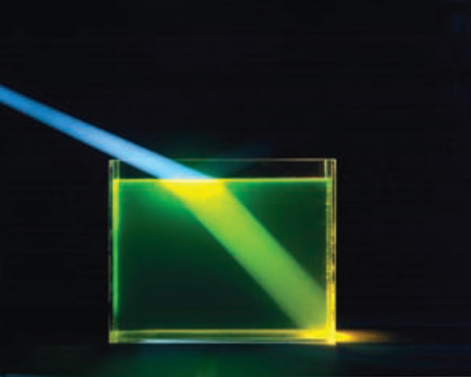
Figure 5.11 You can see the beam of light in air because there are dust particles in the air that scatter the light. You can see the beam of light in the water because there is a substance in the water that fluoresces. (To fluoresce means to give off more visible light than is absorbed.) These “tricks” help you see the beam of light as it bends when it travels from air to water.

6. Dispersion
- White light such as that from the sun is made of waves that possess different wavelengths and frequencies. Dispersion is when the waves separate and bend when they travel from one medium to another.

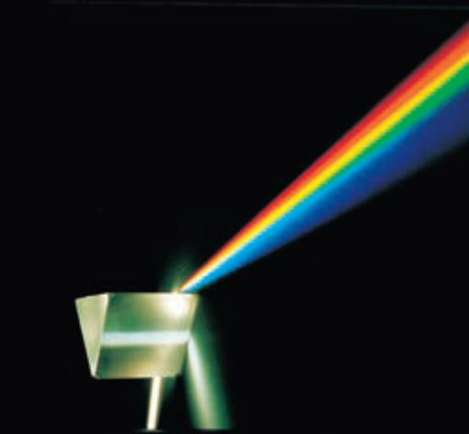

Figure 4.19 A prism refracts light into different colours.


